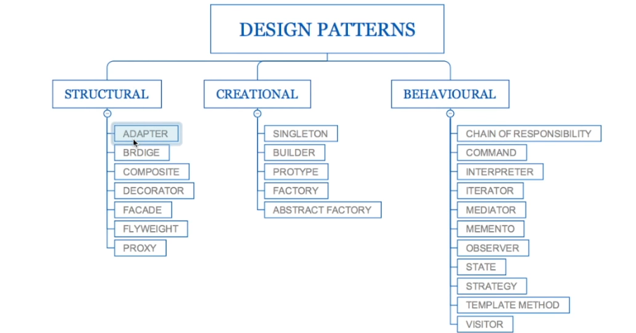

**CREATIONAL DESIGN PATTERNS**

1. Singleton Pattern:

Static in nature.

Thread safe

Private constructor

No parameters to the constructor

//Example of singleton in general use

* + - Runtime.*getRuntime*();
    - Spring Bean
    - Logger

Follow the following instructions:

//How to create singleton class

//1. make default constructor private

//2. create class variable and create method getInstance()

//3. Make method static so that it can be called using class name and method must be public so that it can be accessed outside the package

//4. As per the rule of static method must return static variable so make *soleInstance* class variable as static and private to package.

**package** com.java.design.pattern.singleton;

**class** SingletonClass { // default class

// static is used to make it class level access no need created object, Volatile forces the compiler not to cache the variable, assigning null make lazy creation of object. Not eager

**private** **static** **volatile** SingletonClass *soleInstance* = **null**;

// by making private new object can’t be created outside the class scope using new keyword.

**private** SingletonClass() {

}

// below method help in lazy creating of object, soleInstance must be static because static method can use only static member variable. In multi thread environment make method synchronized and double check is required not to get half cooked instance.

**public** **static** SingletonClass getInstance() {

**if**(*soleInstance* == **null**) { // single check

**synchronized**(SingletonClass.**class**) {

**if**(*soleInstance* == **null**) // double check

*soleInstance* = **new** SingletonClass();

}

}

**return** *soleInstance*;

}

}

//file name and class name must be same and that call must be public and that class can only have main method.

**public** **class** Singleton{

**public** **static** **void** main(String args[]) {

SingletonClass s1 = SingletonClass.*getInstance*();

SingletonClass s2 = SingletonClass.*getInstance*();

//can’t create variable not of scope

//SingletonClass s3 = new SingletonClass();

*print*("S1", s1);

*print*("S2", s2);

//print("s3", s3);

//Class clazz =

}

**private** **static** **void** print(String string, SingletonClass s2) {

// **TODO** Auto-generated method stub

System.***out***.println("Hash code of " + string + " : " +s2.hashCode());

}

}

Disadvantage:

* Over usage.
* Unit Testing is pain. Injection of object and mocking is difficult
* Slow down the system because of Thread safe.
* Confused with factory design pattern (with argument)

(example: Calendar cl = Calendar.getInstance(); which will return different object and is factor pattern)

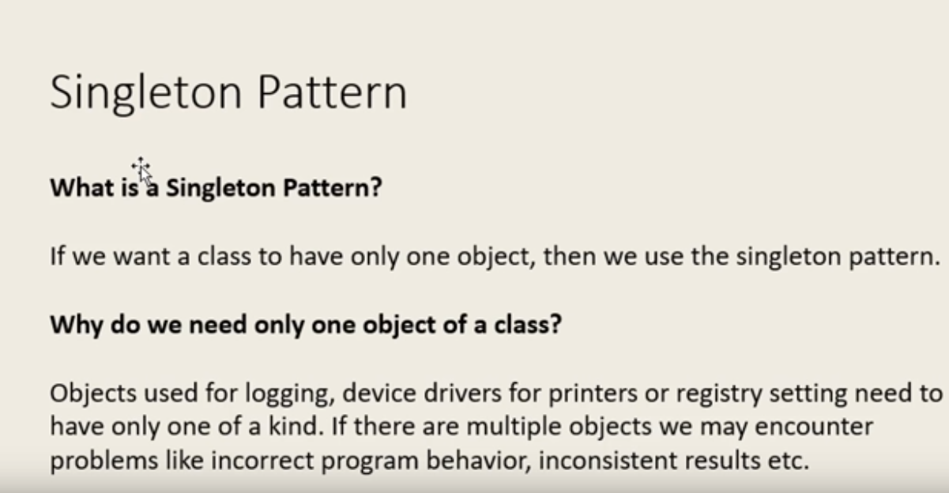

1. Factory Pattern: (Interface aspect )

Doesn’t expose instantiation or the creation logic

Subclasses create the object.

Common Abstract/Interface

Framework, the client/the implementation uses the factories.

* Forces to implement Interface.
* Create the class which create the object for u.
* One place to create the object.

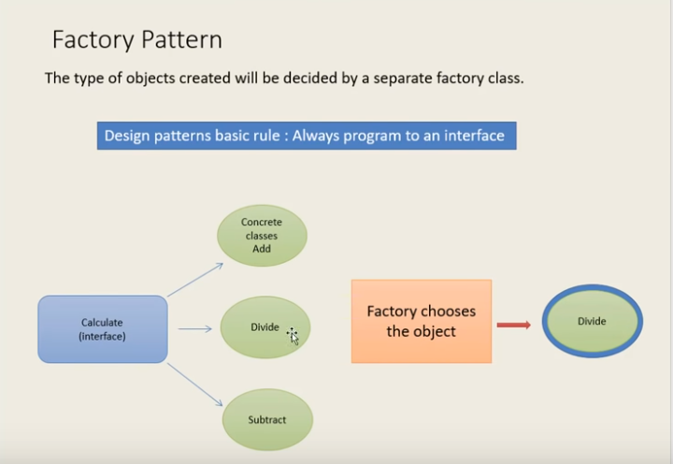

**public** **interface** Calculator {

**public** **void** calculate(**int** a , **int** b);

}

**public** **class** Add **implements** Calculator{

**public** **void** calculate(**int** a, **int** b) {

System.***out***.println("a + b is" + (a+b));

}

}

**public** **class** Divide **implements** Calculator{

**public** **void** calculate(**int** a, **int** b) {

System.***out***.println("Dividtion of a and b " + (a/b));

}

}

**public** **class** Sub **implements** Calculator{

**public** **void** calculate(**int** a , **int** b) {

System.***out***.println(" a - b is " + (a-b));

}

}

//This will hide object creation from user.

**public** **class** CalculateFactory {

**public static** Calculator getCalculator(String opt) {

Calculator c;

**if**(opt.equals("add")) {

c= **new** Add();

}**else** **if**(opt.equals("sub")) {

c= **new** Sub();

}**else** {

c = **new** Divide();

}

**return** c;

}

}

**public** **class** Test {

**public** **static** **void** main(String[] args) {

// **TODO** Auto-generated method stub

Scanner keyboard = **new** Scanner(System.***in***);

Calculator obj;

System.***out***.println("Enter the value of a and b");

**int** a = keyboard.nextInt();

**int** b = keyboard.nextInt();

System.***out***.println("Enter operation to be performed");

String opt= keyboard.next();

obj = CalculateFactory.getCalculator(opt);

obj.calculate(a, b);

}

}

Example:

* Calendar cl = Calendar.getInstance();
* NumberFormate

Disadvantage:

* Complex pattern
* Creation in subclass, hides implementation of class
* Refactoring is complex.

1. Abstract Factory Design Pattern.

Factory of factory / related object / collection of factories.

Common Abstract / Interface

Subclasses create the object.

**package** com.java.design.pattern.abstractfactorypattern;

**public** **abstract** **class** AbstractFactory {

//normal calculator

//Scientific calculator

//return CalFactory

**public** **static** CalFactory getFactory(CalType caltype) {

**switch** (caltype) {

**case** ***NORMAL***:

**return** **new** NormalCalFactory();

**case** ***SCIENTIFIC***:

**return** **new** ScientificCalFactory();

**default**:

**return** **null**;

}

}

}

**package** com.java.design.pattern.abstractfactorypattern;

**public** **enum** CalType {

***NORMAL***,

***SCIENTIFIC***

}

**package** com.java.design.pattern.abstractfactorypattern;

**public** **interface** CalFactory {

Calculator create(String type);

}

**package** com.java.design.pattern.abstractfactorypattern;

**public** **class** NormalCalFactory **implements** CalFactory {

@Override

**public** Calculator create(String type) {

// **TODO** Auto-generated method stub

**switch** (type) {

**case** "add":

**return** **new** Add();

**case** "sub":

**return** **new** Sub();

**case** "div":

**return** **new** Divide();

**default**:

**return** **null**;

}

}

}

**package** com.java.design.pattern.abstractfactorypattern;

**public** **class** ScientificCalFactory **implements** CalFactory {

@Override

**public** Calculator create(String type) {

// **TODO** Auto-generated method stub

**switch** (type) {

**case** "square":

**return** **new** SquareRoot();

**default**:

**return** **null**;

}

}

}

**package** com.java.design.pattern.abstractfactorypattern;

**public** **class** SquareRoot **implements** Calculator {

@Override

**public** **void** calculate(**int** a, **int** b) {

// **TODO** Auto-generated method stub

System.***out***.println("Square root of the two number a*a + b*b " + (a*a + b*b));

}

}

**package** com.java.design.pattern.abstractfactorypattern;

**public** **class** TestAbstractFactoryPattern {

**public** **static** **void** main(String[] args) {

// **TODO** Auto-generated method stub

AbstractFactory.*getFactory*(CalType.***NORMAL***).create("add").calculate(1, 1);

AbstractFactory.*getFactory*(CalType.***SCIENTIFIC***).create("square").calculate(11, 11);

}

}

Example:

DocumentBuilderFactory.newInstance().newDocumentBuilder().parse(file)

Disadvantages:

* The code creation is complex
* Refactoring factory
* More control to client.

1. Builder Design Pattern

Builder design pattern is used for when we are writing lot of API, generally used in Test cases when mocking the objects and values of POJOs.

Is used when u want to create lot of object with multiple values in more immutable way.

**package** com.java.design.pattern.builderDesignPattern;

**public** **class** Phone {

**public** **static** **class** Builder{

**private** String frontPanel;

**private** String backPanel;

**private** String processor;

**private** String camera;

**public** Phone build() {

**return** **new** Phone(**this**);

}

**public** Builder frontPanel(String frontPanel) {

**this**.frontPanel=frontPanel;

**return** **this**;

}

**public** Builder backPanel(String backPanel) {

**this**.backPanel=backPanel;

**return** **this**;

}

**public** Builder processor(String processor) {

**this**.processor=processor;

**return** **this**;

}

**public** Builder camera(String camera) {

**this**.camera=camera;

**return** **this**;

}

}

**private** String frontPanel;

**private** String backPanel;

**private** String processor;

**private** String camera;

**public** Phone(Builder builder) {

// **TODO** Auto-generated constructor stub

**this**.frontPanel=builder.frontPanel;

**this**.backPanel=builder.backPanel;

**this**.camera=builder.camera;

**this**.processor= builder.processor;

}

**public** String getFrontPanel() {

**return** frontPanel;

}

**public** String getBackPanel() {

**return** backPanel;

}

**public** String getProcessor() {

**return** processor;

}

**public** String getCamera() {

**return** camera;

}

@Override

**public** String toString() {

StringBuilder builder2 = **new** StringBuilder();

builder2.append("Phone [frontPanel=");

builder2.append(frontPanel);

builder2.append(", backPanel=");

builder2.append(backPanel);

builder2.append(", processor=");

builder2.append(processor);

builder2.append(", camera=");

builder2.append(camera);

builder2.append("]");

**return** builder2.toString();

}

}

**package** com.java.design.pattern.builderDesignPattern;

**public** **class** Test {

**public** **static** **void** main(String[] args) {

// **TODO** Auto-generated method stub

Phone.Builder builder = **new** Phone.Builder()

.backPanel("Sand Panel")

.frontPanel("glass finish")

.processor("SnagDragen")

.camera("12 MP");

Phone phone = builder.build();

System.***out***.println(phone);

}

}

Examples:

* String Builder
* Document Builder
* Locale Builder
* Spring Reactive
* MockMvcBuilders

Advantages:

* Solves multiple constructor problem(telescoping Constructors)
* Static inner class (builder class)
* Internal required constructor
* Removes need for the setter.

Disadvantages:

* Immutable
* Inner static class
* Design first pattern
* Complex

**STRUCTURAL DESIGN PATTERNS**

1. Adopter Design Pattern:

Is used when we make interface with legacy system.

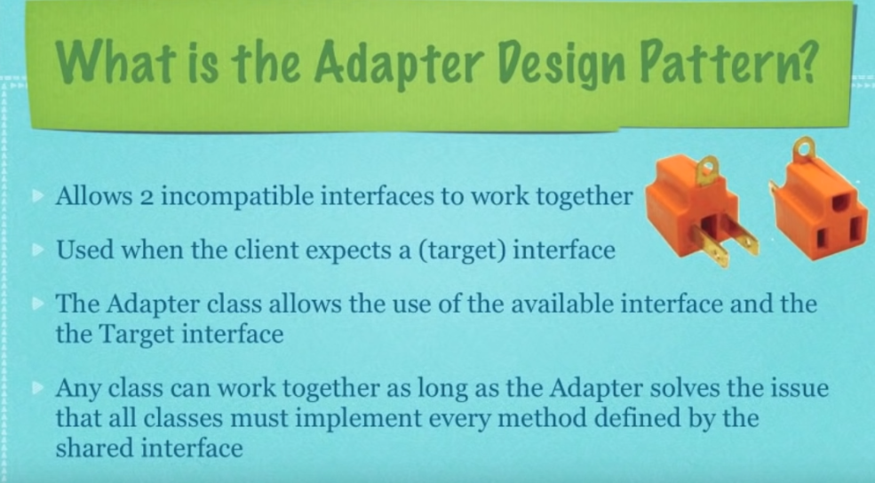

**package** com.java.design.pattern.adopterpattern;

**public** **interface** AndroidPhone {

**void** changer();

}

**package** com.java.design.pattern.adopterpattern;

**public** **class** OnePlus5 **implements** AndroidPhone {

@Override

**public** **void** changer() {

// **TODO** Auto-generated method stub

System.***out***.println("Chanrging OnePlus5 phone");

}

}

**package** com.java.design.pattern.adopterpattern;

**public** **class** AndriodCharger {

**public** **void** charger(AndroidPhone androidPhone) {

androidPhone.changer();

}

}

**package** com.java.design.pattern.adopterpattern;

**public** **interface** IPhone {

**void** changer();

}

**package** com.java.design.pattern.adopterpattern;

**public** **class** IPhoneX **implements** IPhone {

@Override

**public** **void** changer() {

// **TODO** Auto-generated method stub

System.***out***.println("Charging IPhone x");

}

}

**package** com.java.design.pattern.adopterpattern;

**public** **class** IPhoneCharger {

**public** **void** charger(IPhone iphone) {

iphone.changer();

}

}

**package** com.java.design.pattern.adopterpattern;

**public** **class** AndroidPhoneWithIPhoneChargerAdopter **implements** IPhone{

AndroidPhone androidPhone;

AndroidPhoneWithIPhoneChargerAdopter(AndroidPhone androidPhone){

**this**.androidPhone = androidPhone;

}

@Override

**public** **void** changer() {

// **TODO** Auto-generated method stub

androidPhone.changer();

}

}

**package** com.java.design.pattern.adopterpattern;

**public** **class** AdopterExample {

**public** **static** **void** main(String arg[]) {

AndriodCharger andriodCharger = **new** AndriodCharger();

AndroidPhone oneplus = **new** OnePlus5();

andriodCharger.charger(oneplus);

IPhoneCharger iPhoneCharger = **new** IPhoneCharger();

IPhone iPhone = **new** IPhoneX();

iPhoneCharger.charger(iPhone);

AndroidPhoneWithIPhoneChargerAdopter androidPhoneWithIPhoneChargerAdopter = **new** AndroidPhoneWithIPhoneChargerAdopter(oneplus);

androidPhoneWithIPhoneChargerAdopter.changer();

}

}

Example:

* Arrays.asList()

Disadvantages:

* No new functionality it will violates principle(if we add the it will become decorative design pattern)
* Multiple adopter.

1. Composite Design Pattern:

* Is used to represent tree structure
* Components
* Leaf
* Composite

Disadvantages:

* Very costly to create more composite implementation
* Overly simple

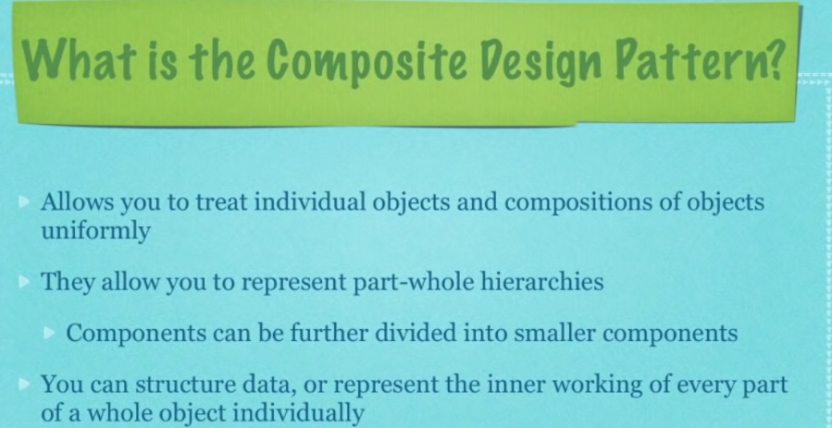

**package** com.java.design.pattern.compositeDesignPattern;

**public** **abstract** **class** Employee {

**protected** String name;

**protected** Integer empId;

**protected** Long salary;

**public** Employee(String name, Integer empId, Long salary) {

**super**();

**this**.name = name;

**this**.empId = empId;

**this**.salary = salary;

}

**public** **abstract** String toString();

**public** **void** add(Employee employee) {

}

**public** **void** remove(Employee employee) {

}

}

**package** com.java.design.pattern.compositeDesignPattern;

**public** **class** Developer **extends** Employee {

**public** Developer(String name, Integer empId, Long salary) {

**super**(name, empId, salary);

// **TODO** Auto-generated constructor stub

}

@Override

**public** String toString() {

// **TODO** Auto-generated method stub

StringBuilder builder = **new** StringBuilder("Developer: ");

builder.append(" ");

builder.append(name);

builder.append(" , ");

builder.append(empId);

**return** builder.toString();

}

}

package com.java.design.pattern.compositeDesignPattern;

import java.util.ArrayList;

import java.util.List;

public class Lead extends Employee {

List<Employee> developer = new ArrayList<>();

public Lead(String name, Integer empId, Long salary) {

super(name, empId, salary);

// TODO Auto-generated constructor stub

}

@Override

public void add(Employee employee) {

developer.add(employee);

}

@Override

public void remove(Employee employee) {

developer.remove(employee);

}

@Override

public String toString() {

// TODO Auto-generated method stub

StringBuilder builder = new StringBuilder("Lead: ");

builder.append(" ");

builder.append(name);

builder.append(" , ");

builder.append(empId);

builder.append(" Developer List:" + "--------------");

developer.forEach(

employee -> builder.append(employee.toString())

);

return builder.toString();

}

}

package com.java.design.pattern.compositeDesignPattern;

import java.util.ArrayList;

import java.util.List;

public class Manager extends Employee {

List<Employee> report = new ArrayList<>();

public Manager(String name, Integer empId, Long salary) {

super(name, empId, salary);

// TODO Auto-generated constructor stub

}

@Override

public void add(Employee employee) {

report.add(employee);

}

@Override

public void remove(Employee employee) {

report.remove(employee);

}

@Override

public String toString() {

// TODO Auto-generated method stub

StringBuilder builder = new StringBuilder("Manager: ");

builder.append(" ");

builder.append(name);

builder.append(" , ");

builder.append(empId);

builder.append(" Developer List:" + "--------------");

report.forEach(

employee -> builder.append(employee.toString())

);

return builder.toString();

}

}

**package** com.java.design.pattern.compositeDesignPattern;

**public** **class** CompositeExample {

**public** **static** **void** main(String[] args) {

// **TODO** Auto-generated method stub

Employee dev1 = **new** Developer("sachin", 1, 1120L);

Employee dev2 = **new** Developer("Anish", 2, 30L);

Employee dev3 = **new** Developer("Anand", 3, 320L);

Employee dev4 = **new** Developer("crish", 4, 23L);

Employee dev5 = **new** Developer("mike", 5, 23L);

Employee dev6 = **new** Developer("lee", 6, 220L);

Employee lead1 = **new** Lead("Raja", 7, 229L);

Employee lead2 = **new** Lead("Sekhar", 8, 229L);

lead1.add(dev1);

lead1.add(dev2);

lead1.add(dev3);

lead1.add(dev4);

System.***out***.println(lead1.toString());

lead2.add(dev5);

lead2.add(dev6);

System.***out***.println(lead2.toString());

Employee manager = **new** Manager("Naga", 9, 23833L);

manager.add(lead1);

manager.add(lead2);

System.***out***.println(manager.toString());

}

}

1. **Decorator Design Pattern:**

* Is used in wrapper
* Add the functionality and Behaviors without disturbing parent class.
* Single responsibility principle.
* Dynamically compose behaviors
* Inheritance and composition

**package** com.java.design.pattern.DecoratorDesignPattern;

**public** **interface** Phone {

String build();

}

**package** com.java.design.pattern.DecoratorDesignPattern;

**public** **class** BasicPhone **implements** Phone {

@Override

**public** String build() {

// **TODO** Auto-generated method stub

**return** "Screen, camera and processor";

}

}

**package** com.java.design.pattern.DecoratorDesignPattern;

//Decorator

**public** **abstract** **class** SmartPhone **implements** Phone {

Phone basicPhone;

**public** SmartPhone(Phone basicPhone) {

**this**.basicPhone=basicPhone;

}

@Override

**public** String build() {

// **TODO** Auto-generated method stub

**return** basicPhone.build();

}

}

**package** com.java.design.pattern.DecoratorDesignPattern;

**public** **class** AndriodPhone **extends** SmartPhone {

**public** AndriodPhone(Phone basicPhone) {

**super**(basicPhone);

// **TODO** Auto-generated constructor stub

}

@Override

**public** String build() {

// **TODO** Auto-generated method stub

**return** basicPhone.build() + addOs();

}

**private** String addOs() {

// **TODO** Auto-generated method stub

**return** "Andriod OS v9.0.9";

}

}

**package** com.java.design.pattern.DecoratorDesignPattern;

**public** **class** IPhone **extends** SmartPhone {

**public** IPhone(Phone basicPhone) {

**super**(basicPhone);

// **TODO** Auto-generated constructor stub

}

@Override

**public** String build() {

// **TODO** Auto-generated method stub

**return** basicPhone.build() + addOs();

}

**private** String addOs() {

// **TODO** Auto-generated method stub

**return** " IOS v13.0.3";

}

}

**package** com.java.design.pattern.DecoratorDesignPattern;

**public** **class** DecoratorExample {

**public** **static** **void** main(String arg[]) {

Phone androidPhone = **new** AndriodPhone(**new** BasicPhone());

System.***out***.println(androidPhone.build());

Phone iphone = **new** IPhone(**new** BasicPhone());

System.***out***.println(iphone.build());

}

}

Disadvantages:

* New class for every new feature.
* Number of object are more.
* More complex for the client.

1. Façade Design Pattern

* Used to make API easy to use. By Creating façade class
* Is used to hide implementation and unclear code. Reduce the dependences
* Does not required any interface. Internally create composition.
* Usually used for refactoring pattern.

**package** com.java.design.pattern.facadepattern;

**public** **interface** Phone {

String build();

}

**package** com.java.design.pattern.facadepattern;

**public** **class** IPhone **implements** Phone {

@Override

**public** String build() {

// **TODO** Auto-generated method stub

**return** "build the IPhone";

}

}

**package** com.java.design.pattern.facadepattern;

**public** **class** OnePluse **implements** Phone {

@Override

**public** String build() {

// **TODO** Auto-generated method stub

**return** "building OnePluse Phone";

}

}

**package** com.java.design.pattern.facadepattern;

**public** **class** NokiaPhone **implements** Phone {

@Override

**public** String build() {

// **TODO** Auto-generated method stub

**return** "Building NokiaPhone";

}

}

**package** com.java.design.pattern.facadepattern;

**public** **class** FacadeClass {

IPhone iphone;

OnePluse oneplus;

NokiaPhone nokiaPhone;

FacadeClass(){

iphone = **new** IPhone();

oneplus = **new** OnePluse();

nokiaPhone = **new** NokiaPhone();

}

String BuildIphone() {

**return** iphone.build();

}

String BuildAndriodPhonce() {

**return** oneplus.build();

}

String BuildWindowsPhone() {

**return** nokiaPhone.build();

}

}

**package** com.java.design.pattern.facadepattern;

**public** **class** FacadeExample {

**public** **static** **void** main(String[] args) {

// **TODO** Auto-generated method stub

FacadeClass facadeClass=**new** FacadeClass();

System.***out***.println(facadeClass.BuildIphone());

System.***out***.println(facadeClass.BuildAndriodPhonce());

System.***out***.println(facadeClass.BuildWindowsPhone());

}

}

Disadvantages:

* Overusing the pattern.
* Used clean up code

1. Template method Pattern: (Abstracted Class)

* Subclass deicide how to implement steps in the algorithm.
* Make sequence step in to one method.
* Make the common method as method of super class
* Make super class as Abstract class
* Method as abstract method.

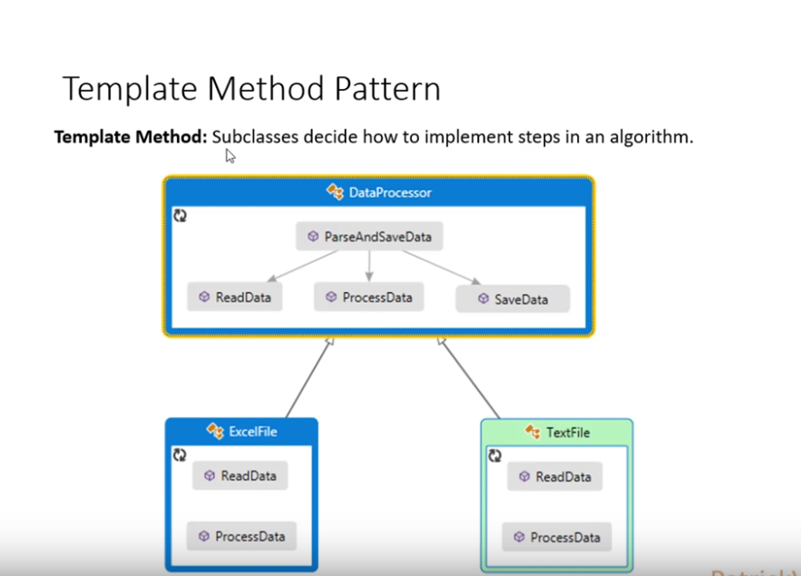

**public** **abstract** **class** DataStore {

**public** **void** readProcessAndSave() {

readData();

processFile();

saveFile();

}

**public** **abstract** **void** readData();

**public** **abstract** **void** processFile();

**public** **void** saveFile() {

System.***out***.println("Store the file in DB");

}

}

**public** **class** ExcelFile **extends** DataStore{

/*public void readProcessAndSave() {

readData();

processFile();

saveFile();

}*/

**public** **void** readData() {

System.***out***.println("Read the Excel file");

}

**public** **void** processFile() {

System.***out***.println("Process the excel file");

}

/*public void saveFile() {

System.out.println("Store the file in DB");

}*/

}

**public** **class** WordFile **extends** DataStore {

/*public void readProcessAndSave() {

readData();

processFile();

saveFile();

}*/

**public** **void** readData() {

System.***out***.println("Read the Word file");

}

**public** **void** processFile() {

System.***out***.println("Process the Word file");

}

/*public void saveFile() {

System.out.println("Store the file in DB");

}*/

}

**public** **class** Test {

**public** **static** **void** main(String[] args) {

// **TODO** Auto-generated method stub

ExcelFile obj = **new** ExcelFile();

/*obj.readData();

obj.processFile();

obj.saveFile();*/

obj.readProcessAndSave();

WordFile obj1 = **new** WordFile();

/*obj1.readData();

obj1.processFile();

obj1.saveFile();*/

obj1.readProcessAndSave();

}

}

1. Strategy Design Pattern: (Encapsulation and inheritance)

You use this pattern if you need to dynamically change an algorithm used by an object at run time.

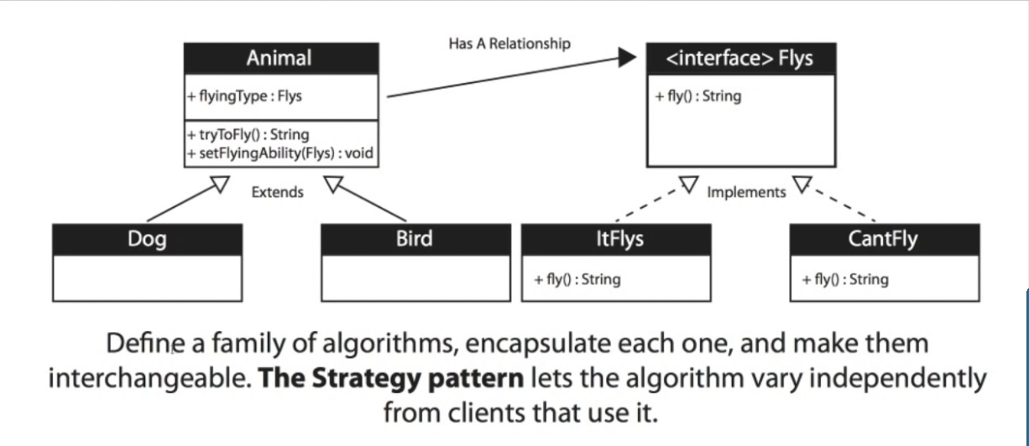

**public** **interface** Fly {

String flymessage();

}

**class** CanFly **implements** Fly{

@Override

**public** String flymessage() {

// **TODO** Auto-generated method stub

**return** "It can fly";

}

}

**class** CantFly **implements** Fly{

@Override

**public** String flymessage() {

// **TODO** Auto-generated method stub

**return** "It Can't Fly";

}

}

**public** **class** Animal {

**private** String name;

**private** **int** weight;

**private** String sound;

**private** Fly fly;

**public** String getName() {

**return** name;

}

**public** **void** setName(String name) {

**this**.name = name;

}

**public** **int** getWeight() {

**return** weight;

}

**public** **void** setWeight(**int** weight) {

**if**(weight > 0) {

**this**.weight = weight;

}**else** {

System.***out***.println("weight must be greater than zero");

}

}

**public** String getSound() {

**return** sound;

}

**public** **void** setSound(String sound) {

**this**.sound = sound;

}

**public** Fly getFly() {

**return** fly;

}

**public** **void** setFly(Fly fly) {

**this**.fly = fly;

}

}

**public** **class** Birds **extends** Animal{

**public** Birds() {

**super**();

setSound("Twity");

setFly(**new** CanFly());

}

}

**public** **class** Dog **extends** Animal {

**public** Dog() {

**super**();

setSound("Barks");

setFly(**new** CantFly());

}

}

**public** **class** PlayWithAnimal {

**public** **static** **void** main(String[] args) {

// **TODO** Auto-generated method stub

Animal dog = **new** Dog();

Animal bird = **new** Birds();

dog.setWeight(-1);

System.***out***.println("Dog :" + dog.getSound() + dog.getFly().flymessage());

System.***out***.println("Birds :" + bird.getSound() + bird.getFly().flymessage());

}

}

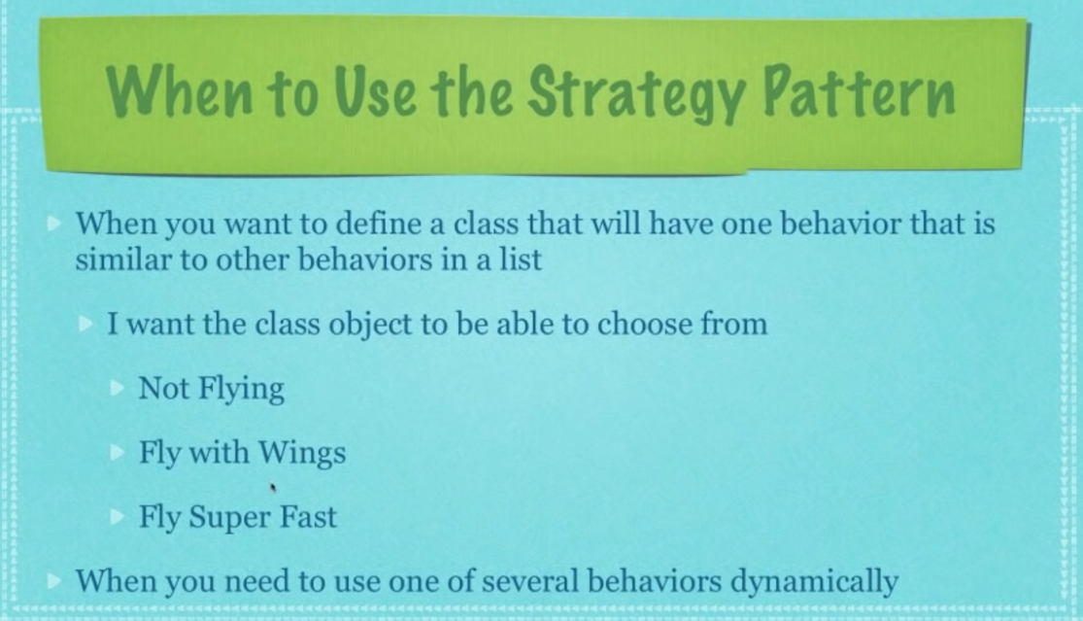

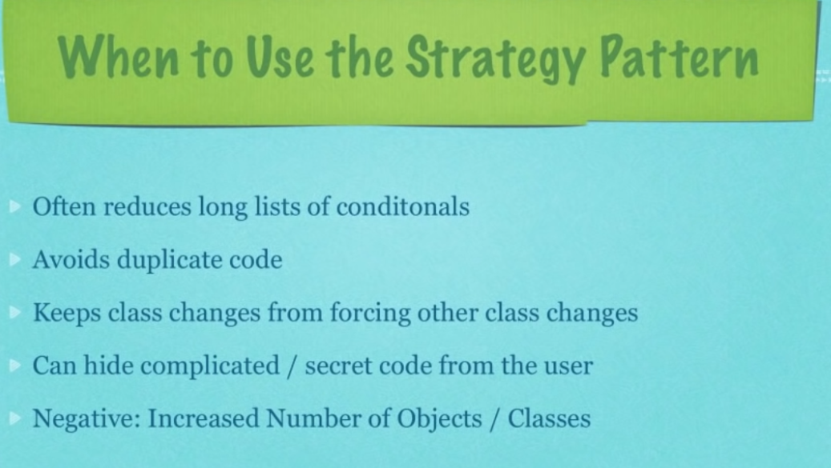

1. Façade Design Pattern

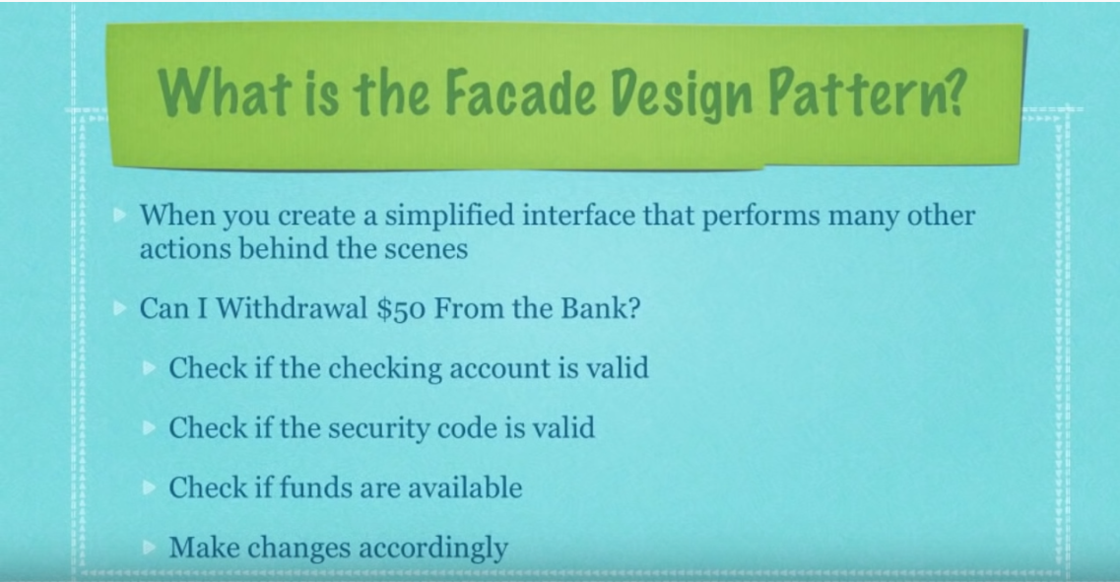

**public** **class** AccountNumberChecker {

**private** **double** accoutNamber = 112123;

**public** **double** getAccoutNamber() {

**return** accoutNamber;

}

**public** **void** setAccoutNamber(**double** accoutNamber) {

**this**.accoutNamber = accoutNamber;

}

**public** **boolean** checkAccoutNumber(**double** accNumber) {

**if**(accNumber == getAccoutNamber()) {

**return** **true**;

}**else** {

**return** **false**;

}

}

}

**public** **class** SecurityCodeChecker {

**private** **int** secCode = 123;

**public** **int** getSecCode() {

**return** secCode;

}

**public** **void** setSecCode(**int** secCode) {

**this**.secCode = secCode;

}

**public** **boolean** checkSecurityCode(**int** code) {

**if**(code == getSecCode()) {

**return** **true**;

}**else** {

**return** **false**;

}

}

}

**public** **class** FundChecker {

**public** **int** amount = 500;

**public** **int** getAmount() {

**return** amount;

}

**public** **void** setAmount(**int** amount) {

**this**.amount = amount;

}

**public** **void** increaseFund(**int** fund) {

**this**.amount =+ fund;

}

**public** **void** decreaseFund(**int** fund) {

**this**.amount =- fund;

}

**public** **boolean** enoughFund(**int** amt) {

**if**(getAmount() > amt) {

decreaseFund(amt);

**return** **true**;

}**else** {

**return** **false**;

}

}

}

**public** **class** FacadeBankDetails {

**private** **int** accoutname;

**private** **int** pin;

**private** AccountNumberChecker accNumber;

**private** SecurityCodeChecker accPin;

**private** FundChecker accFund;

**public** FacadeBankDetails(**int** accnumber , **int** pin) {

**this**.accoutname=accnumber;

**this**.pin = pin;

**this**.accNumber = **new** AccountNumberChecker();

**this**.accPin = **new** SecurityCodeChecker();

**this**.accFund = **new** FundChecker();

}

**public** **int** getAccoutname() {

**return** accoutname;

}

**public** **void** setAccoutname(**int** accoutname) {

**this**.accoutname = accoutname;

}

**public** **int** getPin() {

**return** pin;

}

**public** **void** setPin(**int** pin) {

**this**.pin = pin;

}

**public** **void** cashDeposite(**int** amt) {

**if**(accNumber.checkAccoutNumber(getAccoutname()) && accPin.checkSecurityCode(getPin())) {

accFund.increaseFund(amt);

System.***out***.println("Transaction is Successfull : Balance is "+ accFund.getAmount());

}**else** {

System.***out***.println("Transcation failed");

}

}

**public** **void** cashWithdraw(**int** amt) {

**if**(accNumber.checkAccoutNumber(getAccoutname()) && accPin.checkSecurityCode(getPin()) && accFund.enoughFund(amt)) {

System.***out***.println("Transaction is Successfull : Balance is "+ accFund.getAmount());

}**else** {

System.***out***.println("Transcation failed");

}

}

}

**public** **class** TestBank {

**public** **static** **void** main(String[] args) {

// **TODO** Auto-generated method stub

FacadeBankDetails bank = **new** FacadeBankDetails(112123,123);

bank.cashDeposite(100);

bank.cashWithdraw(500);

bank.cashDeposite(1000);

}

}

1. Bridge Design Pattern: Abstract Class

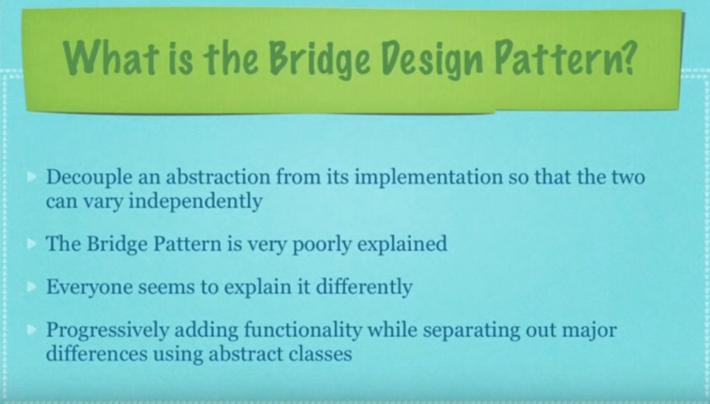

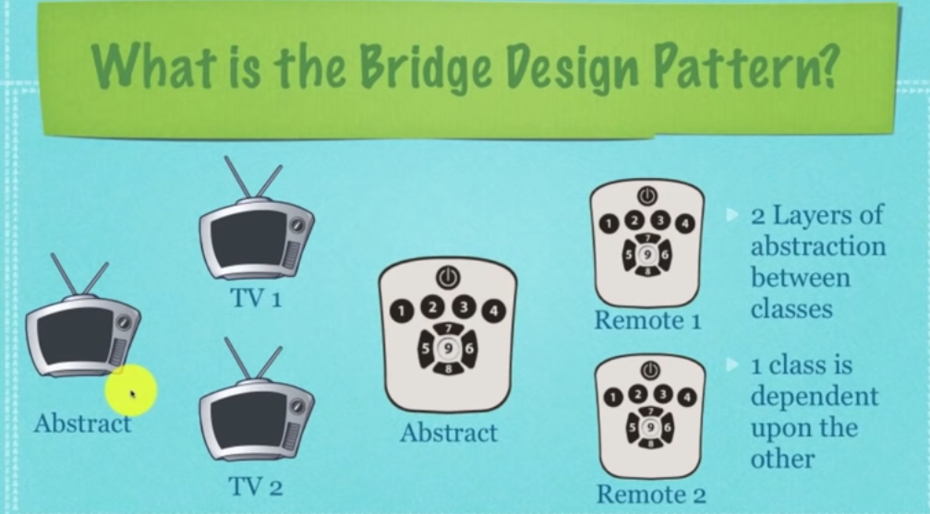

**public** **abstract** **class** EntertainmentDevice {

**public** **int** deviceStatus;

**public** **int** maxSetting;

**public** **int** volumnLevel = 0;

**public** **abstract** **void** pressFive();

**public** **abstract** **void** pressSix();

**public** **void** pressSeven() {

volumnLevel++;

System.***out***.println("Volume is increased " + volumnLevel);

}

**public** **void** pressEight() {

volumnLevel--;

System.***out***.println("volume is decreased " + volumnLevel);

}

**public** **void** deviceFeedback() {

**if**(deviceStatus > maxSetting || deviceStatus < 0) { deviceStatus =0; }

System.***out***.println("On " + deviceStatus);

}

}

**public** **class** TvDevice **extends** EntertainmentDevice {

**public** TvDevice(**int** newDevicesStatus, **int** newMaxSetting) {

// **TODO** Auto-generated constructor stub

deviceStatus = newDevicesStatus;

maxSetting = newMaxSetting;

}

@Override

**public** **void** pressFive() {

// **TODO** Auto-generated method stub

System.***out***.println("chennal down");

deviceStatus--;

}

@Override

**public** **void** pressSix() {

// **TODO** Auto-generated method stub

System.***out***.println("chennal up");

deviceStatus++;

}

}

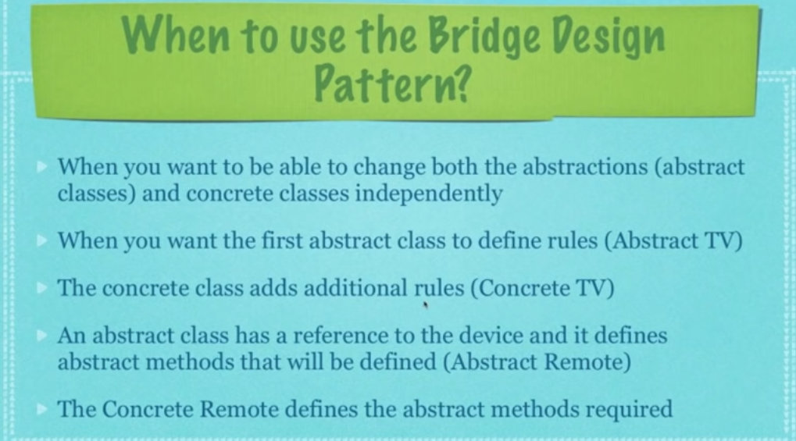

1. State Design Pattern:

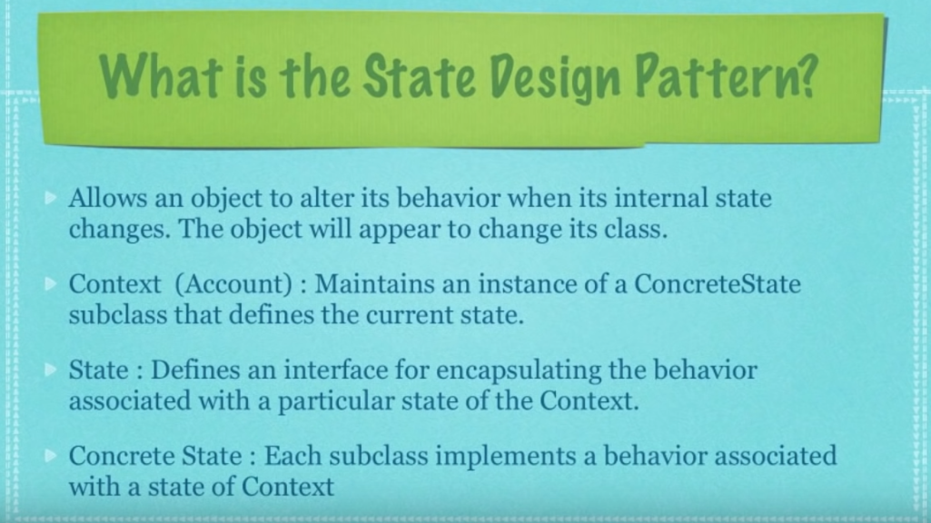

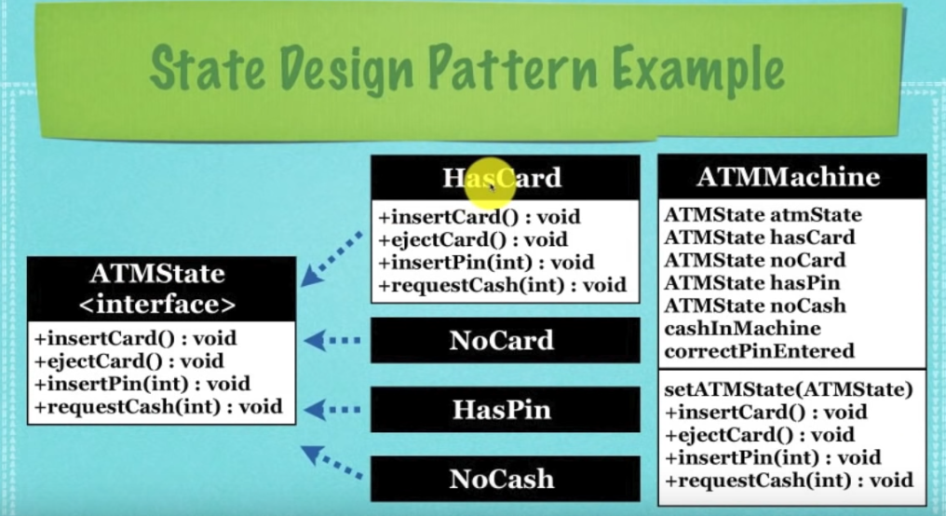

1. Observer Design Pattern : (loose coupling)

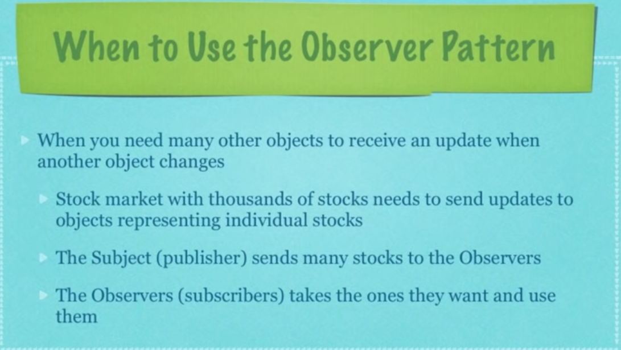

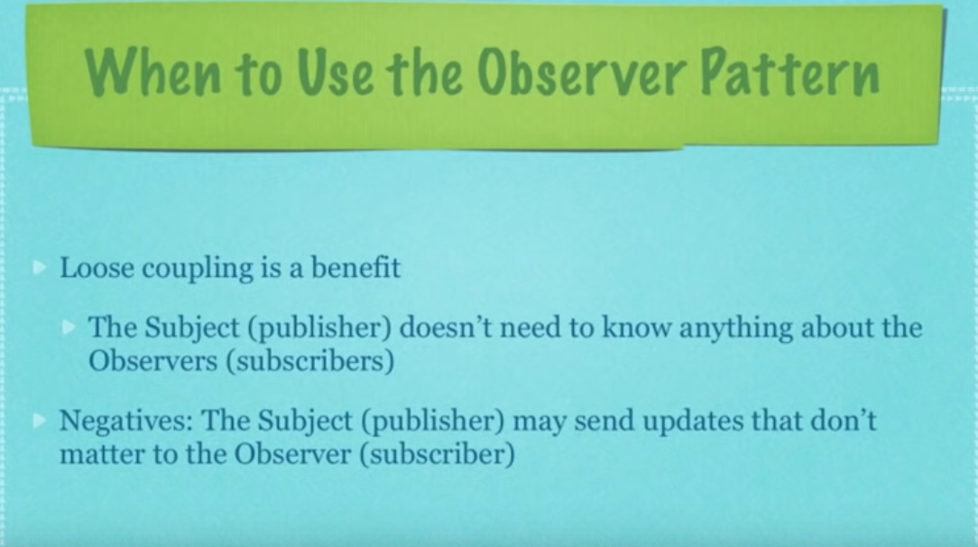

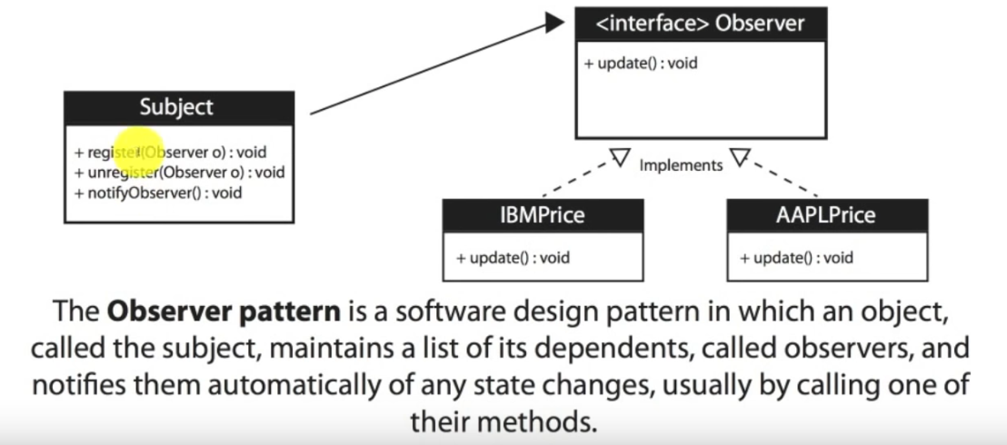

1. Proxy Design Pattern :

